PROJECT | AI-ENHANCED DEPARTMENTAL STORE MANAGEMENT SYSTEM
NAME | - ZAINAB SARFRAZ  - ADEEN TARIQ  - EMAN QASIM
REG NO | - 24-NTU-CS-FL-1289  - 24-NTU-CS-FL-1242  - 24-NTU-CS-FL-1255
SEMESTER | 3rd
COURSE CODE/TITLE | COC-2074L/DATA STRUCTURES AND ALGORITHMS-LAB
SECTION/DEPARTMENT | BSAI/CS
SUBMITTED TO | MAM. KANWAL KHURSHID
SUBMISSION DATE


DEPARTMENTAL STORE MANAGEMENT SYSTEM
INTRODUCTION:
This project is based on the subject Data Structures and Algorithms (DSA).
The Departmental Store Management System is a simple program developed in C++ that helps manage store products such as items, prices, and quantities.
In this project, arrays are used as the main data structure to store and manage all information.
PROBLEM STATEMENT:
Manual record-keeping in a departmental store is prone to errors and slow retrieval times. By using optimized Arrays and Sorting/Searching Algorithms in C++, we can ensure that product lookup is fast and the inventory is always organized for the manager.
OBJECTIVES:
The main objectives of this project are:
- To use arrays to store product information
- To add and display products
- To update product quantity after sale
- To calculate total bill of purchased items
- To apply basic algorithms like searching
- To improve understanding of arrays in C++
CONCEPTS TO BE IMPLEMENTED:
This project will specifically highlight the following C++ DSA techniques:
- Data Organization (Structs & Arrays): Using a struct to group product data (ID, Name, Price, Quantity) and storing these structures in an Array.
- Searching Algorithms:
- Linear Search: To find items by their name.
- Binary search: To find items by their unique ID (highly efficient for large datasets).
- Sorting Algorithms: * Bubble Sort: To organize products by price (low to high) or by ID.
- Time Complexity Analysis: Comparing O(n) (Linear Search) vs. O (log n) (Binary Search) performance.

SYSTEM FEATURES:
Cashier:
- Product Search: Enter a Product ID to instantly retrieve price and stock details using Binary Search.
- Billing Logic: As items are "scanned," they are added to "Transaction Array."
- Stock Update: The system modifies the specific index in the master array to reduce quantity after a sale (O (1) access).
Inventory Manager:
- Add/Remove Records: Insert new product data into the array or "delete" by shifting elements.
- Organize Inventory: Sort all products by "Stock Quantity" to see which items need urgent restocking.
- Display Records: Traverse the array to print a neatly formatted table of all store items.
Admin:
- Total Income Calculation: Uses a Linear Traversal algorithm to sum up all sales recorded in the transaction array.
- Search by Category: Uses a Linear Search to filter and display only specific types of products (e.g., all "Electronics").
- System Reset: A function to clear the array or resize it (if using dynamic arrays) to start a new business day.
- Binary Search Optimization: The admin can trigger a "Sort by ID" function to ensure that the Cashier's Binary Search always works correctly (since Binary Search requires a sorted array).
Customer:
- Price Filtering: The customer can choose to see products within a specific price range.
- Availability Check: The customer types a product name, and the system tells whether it is In Stock or Out of Stock.
- Virtual Cart: A temporary array that stores the indices of items the customer is interested in before they head to the cashier.
TECHNICAL STACK:
- Language: C++
- Data Structure: Array of Structures (struct Product)
- Algorithm Focus: Linear Search, Binary Search, and Selection Sort.
- Interface: Console-based Menu (using switch-case and loops).
PROJECT ROADMAP:
- Define the Product structure and initialize a fixed-size array.
- Write functions for adding and displaying products (Array Traversal).
- Implement Linear Search for the Cashier's lookup feature.
- Implement Selection Sort to keep the inventory organized by ID.
- Ensure array is sorted before applying Binary Search.
- Add Binary Search once the array is sorted.
CONCLUSION:
The Departmental Store Management System using arrays in C++ is a simple and effective project for understanding basic concepts of Data Structures and Algorithms.
This project shows how arrays can be used to solve real-world problems in an organized way.
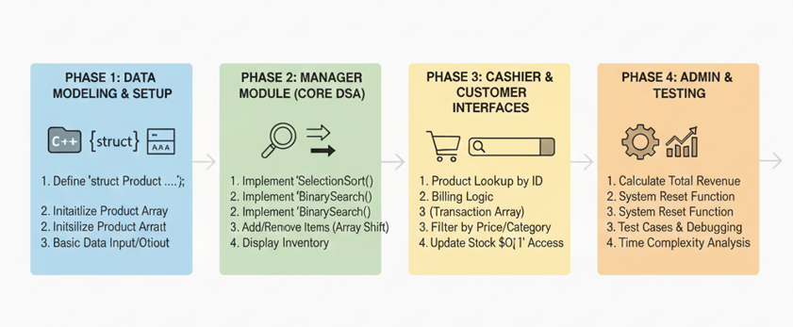
THE END

